Project Design Phase-II
Data Flow Diagram & User Stories

Date | 04 February 2026
Team ID | LTVIP2026TMIDS65419
Project Name | Flavour Fusion: Ai-Driven Recipe Blogging
Maximum Marks | 4 Marks

Data Flow Diagrams:
A Data Flow Diagram (DFD) is a traditional visual representation of the information flows within a system. A neat and clear DFD can depict the right amount of the system requirement graphically. It shows how data enters and leaves the system, what changes the information, and where data is stored.

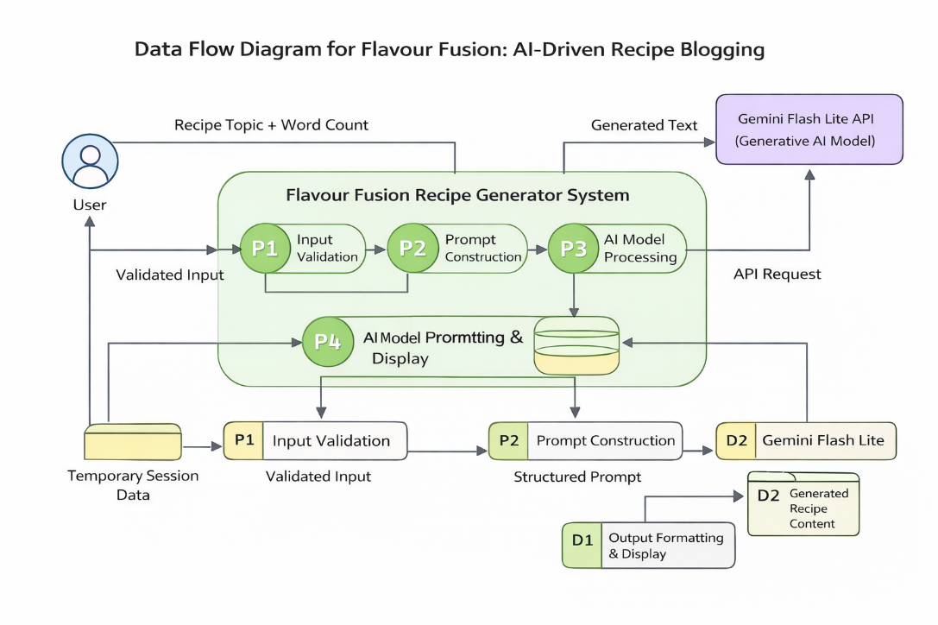

User Stories
Use the below template to list all the user stories for the product.
User Type | Functional Requirement (Epic) | User Story Number | User Story / Task | Acceptance criteria | Priority | Release
Customer (Mobile user) | User Interface Setup | USN-1 | As a user, I can access a Streamlit-based interface to enter a recipe topic and word count. | I can access my account / dashboard | High | Sprint-1
Administrator | Input Validation | USN-2 | As a user, I want the application to validate my inputs before generating the recipe. | I can validate the inputs | High | Sprint-1
Customer Care Executive | AI Model Integration | USN-3 | As a user, I want the system to generate a recipe blog using the Gemini Flash Lite model. | I can integrate model | High | Sprint-2
Administrator | Joke Generation | USN-4 | As a user, I want to see a programming joke while the recipe is being generated. | I can generate a joke for user interaction while recipe generation delayed | Medium | Sprint-2
Customer (Mobile user) | Output Display | USN-5 | As a user, I want to view the generated recipe blog clearly on the screen. | I can see the output of recipe generated | High | Sprint-3
Customer Care Executive | Deployment | USN-6 | As a user, I want the application to be deployed and accessible through the internet. | I can deploy in the system | Medium | Sprint-3

